AWS Backup
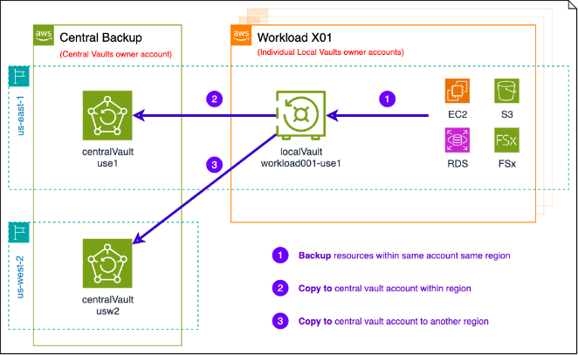
Today we are going to understand one of the most important and often underestimated services in AWS, which is AWS Backup. Whether you are a beginner just starting your cloud journey, an AWS professional managing production workloads, or a security expert responsible for compliance and ransomware protection, this session will help you clearly understand how AWS Backup works and why it is critical in modern cloud environments.
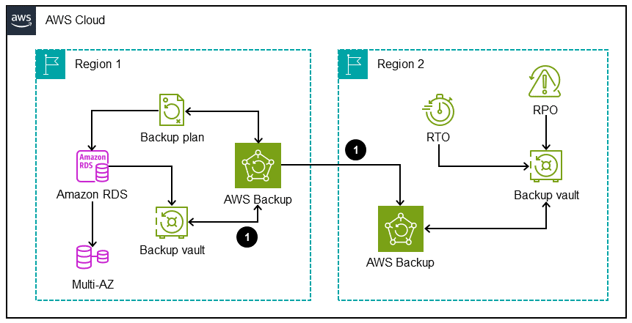
Let us start with a simple question. What is AWS Backup? In very simple words, AWS Backup is a fully managed service from Amazon Web Services that helps you centrally automate and manage backups of your AWS resources. Instead of configuring backups separately for Amazon EBS, Amazon RDS, Amazon DynamoDB, Amazon EFS, and other services, AWS Backup allows you to define backup rules once and apply them across multiple services from one place. It gives you visibility, control, automation, and compliance capabilities in a single dashboard.
Now let us understand why backups are important in cloud environments. Many people think that because data is in the cloud, it is automatically safe. This is a very dangerous assumption. Cloud providers like AWS provide infrastructure availability and durability, but protecting your data from accidental deletion, corruption, ransomware attacks, insider threats, or application errors is still your responsibility. This concept is part of the shared responsibility model. For example, if someone accidentally deletes a production database in Amazon RDS, AWS will not automatically restore it for you unless you have backups configured. Backups are your safety net. They ensure that even if something goes wrong, your business can continue.
It is also important to understand the difference between backup, snapshot, replication, and disaster recovery. A backup is a stored copy of your data that you can restore later. A snapshot is usually a point-in-time copy of storage, such as an EBS snapshot. Replication means copying data continuously or periodically to another location, often another Region. Disaster recovery is a broader strategy that includes backups, replication, failover processes, and recovery plans to ensure business continuity during major outages. AWS Backup focuses mainly on backup and restore, but it also supports cross-Region and cross-account features that help in disaster recovery planning.
Now let us go deeper into what AWS Backup actually does. AWS Backup is a centralized service that allows you to create backup plans. These plans define when backups will run, how long they will be stored, and where they will be stored. It supports multiple AWS services including Amazon EBS volumes, Amazon EC2 instances, Amazon RDS databases, Amazon DynamoDB tables, Amazon EFS file systems, Amazon FSx file systems, and more. Over time, AWS has continued to expand support to additional services.
For beginners, think of AWS Backup as a backup manager. Instead of going into each service individually, you configure everything from one place. For professionals, it reduces operational overhead and improves governance. For security professionals, it enables policy-based backup enforcement and immutable backups using Vault Lock.
Let us understand the core components of AWS Backup. The first component is the Backup Vault. A backup vault is a logical container where your backups are stored. You can think of it like a safe locker in a bank. Inside that locker, your recovery points are stored. Each vault can be encrypted using AWS Key Management Service, also known as AWS KMS, which ensures your backups are encrypted at rest.
The next important component is the Backup Plan. A backup plan defines how and when backups happen. It contains one or more backup rules. For example, you may create a backup plan that says, “Take daily backups at 2 AM and retain them for 30 days.” This is your policy.
Inside the backup plan, you define Backup Rules. A backup rule specifies the schedule, such as daily, weekly, or monthly, the backup window, and the lifecycle settings. Lifecycle settings allow you to move backups to cold storage after a certain number of days and delete them after a retention period. This helps you optimize cost.
Then we have Resource Assignment. This means selecting which resources should follow the backup plan. You can assign resources manually, or you can use tags. Tag-based assignment is very powerful. For example, if you tag all production resources with “Environment = Production,” you can create a backup plan that automatically includes all resources with that tag. This is very useful for large organizations.
Finally, we have Recovery Points. A recovery point is an individual backup copy created at a specific time. When you want to restore data, you select a recovery point and initiate a restore operation.
Now let us talk about backup lifecycle management. Lifecycle management allows you to define how long backups should be kept. For example, daily backups may be kept for 30 days, monthly backups for one year, and yearly backups for seven years. You can also move backups to cold storage to reduce costs. This is important for compliance and cost optimization.
Cross-Region backup is another powerful feature. Suppose your primary workload runs in the Mumbai Region. You can configure AWS Backup to automatically copy backups to another Region, such as Singapore. If the entire Mumbai Region faces an outage, you can restore your data in Singapore. This is a key part of disaster recovery.
Cross-account backup is equally important for security. Many organizations use multiple AWS accounts for isolation. With cross-account backup, you can copy backups to a separate backup account. Even if a production account is compromised by ransomware, the attacker may not have access to the backup account. This provides an additional layer of protection.
AWS Backup Policies are used in AWS Organizations to centrally manage backup settings across multiple accounts. This is especially useful in enterprises. A central security team can enforce backup rules across all accounts without manually configuring each one.
Now let us discuss AWS Backup Vault Lock. This feature provides WORM protection, which means Write Once Read Many. Once enabled, backups cannot be deleted or modified before the retention period expires, even by administrators. This is extremely important for ransomware protection and regulatory compliance. For example, in financial institutions, regulations may require that backups cannot be tampered with. Vault Lock ensures immutability.
Encryption is also a critical topic. AWS Backup uses AWS KMS for encryption. Backups are encrypted at rest. You can use AWS-managed keys or customer-managed keys. For security professionals, using customer-managed keys gives more control over access and auditing.
IAM roles and permissions control who can create, modify, delete, or restore backups. AWS Backup uses a service-linked IAM role to perform backup operations. As a best practice, apply least privilege access. Only authorized personnel should have permission to delete recovery points or modify backup plans.
Monitoring and auditing are handled using services like AWS CloudTrail and Amazon CloudWatch. CloudTrail records API calls, such as who deleted a backup or modified a plan. CloudWatch provides metrics and alarms. For example, you can create an alarm if a backup job fails.
Now let us talk briefly about pricing. AWS Backup pricing depends on the amount of backup storage used, data transfer for cross-Region copies, and restore operations. Cold storage is cheaper than warm storage. There is no upfront cost for creating backup plans. However, you must monitor storage usage to avoid unexpected charges.
Let us now discuss security best practices. Ransomware protection is one of the biggest reasons organizations use AWS Backup. By enabling Vault Lock and cross-account backups, you create immutable and isolated backups. This prevents attackers from deleting your backups.
Least privilege access should always be implemented. Do not give full access to all administrators. Use IAM policies carefully. Monitor backup deletion attempts using CloudTrail.
A multi-account strategy is highly recommended. Maintain a separate backup account. Use AWS Organizations to enforce backup policies across accounts.
Compliance use cases are common in finance and healthcare industries. For example, a healthcare company storing patient data must retain backups for several years due to regulations. AWS Backup lifecycle and Vault Lock features help meet these requirements.
Now let me share some real-life use cases. Imagine a company accidentally deletes a production DynamoDB table. Without backup, the data is permanently lost. With AWS Backup, they can restore the table from a recovery point in minutes.
Consider a ransomware attack where an attacker encrypts EC2 volumes. If immutable backups exist in a separate account, the company can restore clean data and resume operations.
For regulatory compliance, a bank may need to store transaction data backups for seven years. Using lifecycle policies and Vault Lock ensures compliance.
For disaster recovery, a company running an e-commerce platform in one Region can use cross-Region backup. If the primary Region fails, they restore backups in another Region and minimize downtime.
Now let us move to a simple hands-on lab as of February 2026. This lab is designed for beginners using the AWS Management Console.
First, log in to the AWS Management Console and search for AWS Backup in the services menu. Open the AWS Backup dashboard.
To create a Backup Vault, click on “Backup vaults” and then “Create backup vault.” Give it a name such as “Prod-Backup-Vault.” Choose a KMS key. For beginners, you can select the default AWS managed key. Click create. Your vault is ready.
Next, create a Backup Plan. Go to “Backup plans” and click “Create backup plan.” Choose “Build a new plan.” Give it a name such as “Daily-Backup-Plan.” Add a backup rule. Set the backup frequency to daily and choose a time, for example 2 AM. Set retention to 30 days. Select the backup vault you created. Save the plan.
Now assign resources. After creating the plan, click “Assign resources.” You can assign specific resources or use tags. For a simple lab, select a resource such as an EC2 instance or an EBS volume. Ensure the instance exists before this step. Assign the resource.
To run an on-demand backup, go to “Protected resources,” select the resource, and click “Create on-demand backup.” Choose the vault and retention period. Start the backup job. Monitor the job status under “Backup jobs.”
Once the backup is completed, go to “Recovery points,” select the recovery point, and choose “Restore.” Follow the restore wizard. For example, if restoring an EC2 instance, you can restore it as a new instance. Review settings and start the restore job.
Optionally, to enable Vault Lock, go to your backup vault and choose “Edit vault lock.” Configure a retention period and lock configuration. Be very careful because once Vault Lock is in compliance mode, it cannot be removed until the retention period expires.
Finally, verify recovery. Check that the restored resource is working correctly. For example, if you restored an EC2 instance, log in and confirm data is intact.
In terms of cost awareness, remember that you are charged for backup storage used. For a small lab with one EC2 instance and short retention, cost will typically be low, but always delete lab resources after testing to avoid unnecessary charges.
To conclude, AWS Backup is not just a backup tool. It is a centralized data protection solution that supports automation, security, compliance, and disaster recovery. For beginners, it simplifies backup management. For professionals, it reduces operational complexity. For security experts, it provides immutability, encryption, and governance. In today’s world where ransomware and compliance requirements are increasing, AWS Backup is not optional. It is a critical part of a well-architected cloud environment.

